Live Here Love Here Small Grants Scheme 2017  Frequently Asked Questions | 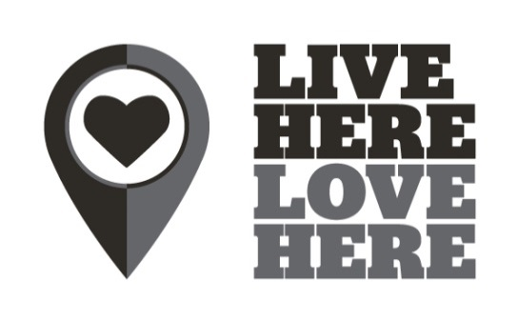

Why aren’t grants available in my Council area?
We approached all Councils to ask for their support and involvement in the Live Here Love Here programme and unfortunately your Council isn’t supporting the programme for this year. We are working hard to secure as much support as possible from all Council areas aiming to extend the small grants scheme.

I work for a partnership organisation/in partnership with others but the project would take place in a non-participating Council area – can I still apply?
The grants are specifically designed for local activity by local volunteers to develop civic pride in local communities. Due to the focus on local activity, both group and work need to take place within the participating Council areas. Councils listed below are funding the grants programme so grants will only be distributed within these areas.
- Antrim and Newtownabbey Borough Council
- Armagh City, Banbridge and Craigavon Borough Council
- Ards and North Down Borough Council
- Belfast City Council
- Derry City and Strabane District Council
- Fermanagh and Omagh District Council
- Mid and East Antrim Borough Council
- Mid Ulster District Council
- Newry, Mourne and Down District Council
- Choice Housing (Areas managed by a Housing Association or Housing Executive in all Council areas)
- NIHE (Areas managed by a Housing Association or Housing Executive in all Council areas)
- McDonald’s (All Council areas)

Would a window basket project be suitable?
Yes, a window basket project would be eligible, provided it is beneficial to your whole community and all items are purchased and your claim is submitted by the deadline on 8th January 2018.

Can the LHLH Small Grant Scheme be used for rent, insurance, running costs for volunteer groups?
No, the scheme will not cover rent, insurance or running costs for volunteer groups. The grants are specifically designed for local activity by local volunteers to develop civic pride in communities.

Can groups make a Partial Claim?
Yes, where agreed, groups can make partial claims as long as the correct information and evidence are provided on the grant claim forms.

Can it be used as a contribution for a bigger project?
No, the scheme will not act as match funding for other projects. The project must be a definitive piece of work demonstrating environmental and community benefits.

Could a group submit an application to pay for rubbish clearance?
If the group outsources the total cost of clearing rubbish then little or no volunteer involvement would be demonstrated. This would result in a low score for volunteer involvement and the project may not be approved.

Is the small grants scheme open to NGOs?
Yes, the scheme is open to NGOs (within supporting council areas). However, the focus of the scheme is on local activism and smaller projects as reflected in the criteria.

Can groups hire specialist equipment such as a digger?
Yes, the scheme can fund the hire of specialist equipment if it is part of the wider volunteer project.

Can purchases be made before the judging date?
The scheme isn’t retrospective, so we cannot reimburse any expenses that have already been incurred; groups would need to wait to make any purchases.

Can groups store plants during winter for use in spring?
Yes, it would be fine to store plants provided all items are purchased and your claim is submitted by the deadline on 8th January 2018.

Do I need to include estimates with the application form?
The application process will not be based on estimates. On the application form you must submit accurate costings of your project. Items should be quoted for as accurately as possible – this is how the judges will score the value for money element of the project. If your project is successful all quotes should then be submitted along with the financial claim form.

Can the group pay for a specialist service/contractor to remove invasive species before they begin a new project?
Yes, contractors can be used to remove invasive species; however the groups need to demonstrate the sustainability of the project in the application.

Can I submit supporting documentation with my application form?
No, additional documents will NOT be considered.

Do applicants have to own relevant land/property to be eligible for funding?
No, but approved access MUST be confirmed and usage agreement established.

